



Telephone: 059 8627226

E-mail: [principal.ballyadams@gmail.com](mailto:principal.ballyadams@gmail.com)

Office: [secretary.ballyadams@gmail.com](mailto:secretary.ballyadams@gmail.com)

Website: www.ballyadamsns.com

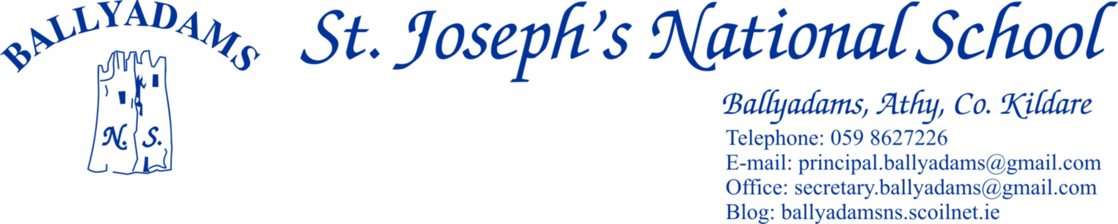

**FAQs - Return to School**

**What date are we returning to school?**

Wednesday 26th October

**Do children have to wear their school uniform?**

There is no reference in public health guidance to daily washing of school uniforms or any clothes. Acting Chief Medical Officer, Dr Ronan Glynn has confirmed no such advice has been issued by health authorities. If parents wish children can alternate between their uniform and PE uniform to allow for washing but it is not required.

**Do children need to have their own hand sanitizer?**

There will be hand sanitizer in each classroom and at the exit and entry points to the playground. Children may bring their own hand sanitizer if they wish but there will be hand sanitizer accessible and provided in the school.

**How will my child know where to go if I can't bring them to their playground area in the morning?**

Members of the teaching staff will be on the school yard in the morning to ensure children know where to go to their Class Bubble and yard area.

**Is there anywhere I can see more information about re – opening arrangements?**

A downloadable letter detailing arrangements for school re – opening is available in the School Reopening section of the school website.

Should any parents have any further queries you may email [principal.ballyadams@gmail.com](mailto:principal.ballyadams@gmail.com) We will update the FAQs if we receive more questions.