



Telephone: 059 8627226

E-mail: [principal.ballyadams@gmail.com](mailto:principal.ballyadams@gmail.com)

Office: [secretary.ballyadams@gmail.com](mailto:secretary.ballyadams@gmail.com)

Website: www.ballyadamsns.com

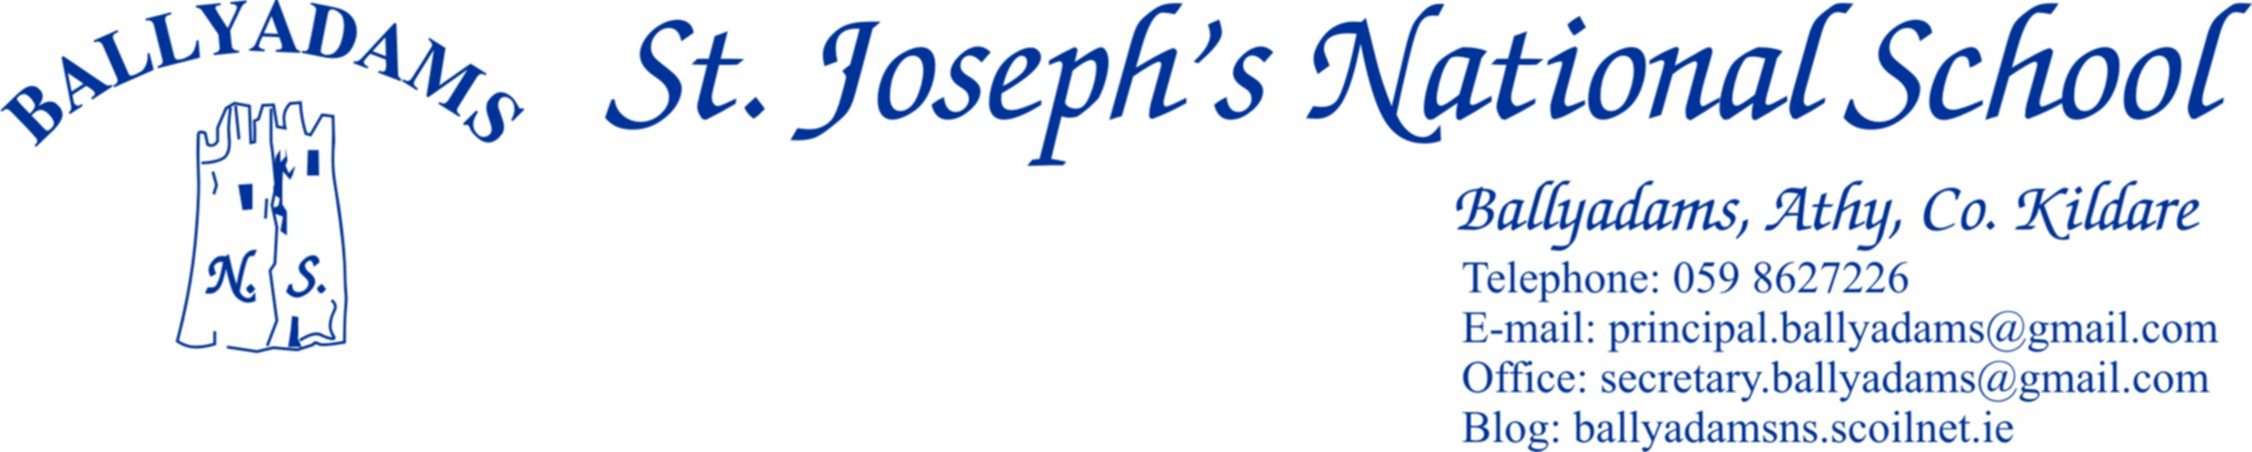

January 24th, 2017

***January Newsletter***

**Parents’ Council**

The Parents’ Council were very busy and proactive in the first term. They ran a number of very successful fundraising events, including the Christmas Raffle, Cake Sale and 2017 Calendar. Thank you once more for your continued support.

**Enrolment**

We are currently enrolling for the 2017/18 school year so please contact Pam in the office if you need an enrolment application form. We’d be grateful if you’d remind friends or neighbours who have children ready to start school that we are open for enrolment.

**St. Vincent de Paul Fun Day**

Well done to 6th Class for organising our annual St. Vincent de Paul ‘Fun Day’ on December 21st. A total of €481 was raised on the day.

**First Holy Communion**

Mr Mullooly’s 2nd Class are continuing their preparations for First Holy Communion on May 13th. First Confessions will be held on Wednesday March 15th at 2pm in Ballyadams Church with light refreshments for pupils and parents in the school hall afterwards.

**Primary Science Fair**

4th Class and 5th Class had a great day out at the RDS Primary Science Fair in Mary Immaculate College, Limerick on Thursday last. Well done to Mrs Murray’s class who impressed the judges and general public with their brilliant project, ‘Why Don’t I Fall Out When the Roller Coaster Loops the Loop?’ Thank you to Mrs Murray for providing the children with the opportunity to take part. There are some photos of the day on the school website.

**Book Fair**

The school book fair will run from Monday March 22nd – 24th. Parents are welcome to come in to the library and examine the books on display with their children. However, I’ll stress that there is no obligation or expectation to purchase books. It is also worth highlighting the excellent service provided free of charge by our local libraries.

**Stradbally Library**

Stradbally Library have asked us to inform you of some of the clubs they are currently running. These include a Lego Club, Children’s Knitting and Crochet Club and Children’s Chess/Draughts Club. Membership of each club is free and they only require parent I.D. and proof of address. Please contact 0578641673 for further details.

**Winter Ready**

I’ll remind parents and pupils to be particularly careful coming to school on these cold mornings. It has been relatively mild of late, but there have been some very frosty morning so please take care when getting out of cars and buses and mind your step on the icy ground.

**Active Schools Flag**

Ms Walsh’s Active Schools committee are busy planning and working towards our Active Flag. Daily yard exercises have begun and each class will also complete a ‘Class Run’ once a week.

**Friendship Week**

We will run a whole-school Friendship Week from Feb 13th – 17th. The theme is Friendship and Belonging and we look forward to exploring the topic with a range of fun based activities.

**Swimming**

2nd Class, 3rd Class and the boys from 4th Class will commence swimming lessons in Portlaoise Leisure Centre on Thursday March 2nd and each Thursday until April 6th.

**Hurling and Camogie**

Hurling coaching for the boys in 4th, 5th and 6th Classes continues every Monday lunch time in the school hall, while camogie coaching for the girls in 4th, 5th and 6th Classes is every Friday. Please bring a hurl and helmet to school on those days. If anyone is finding it difficult to source equipment, please let me know as we have a limited supply of hurls and helmets in the school.

**School Website**

I’ll remind you that the parents’ section of our school website includes links to useful educational websites, previous newsletters, school calendar and a Parents’ Council page. You can visit us out at [www.ballyadamsns.com](http://www.ballyadamsns.com)

**Parking and Morning Supervision**

Once again, I’ll remind ***some*** parents that the car park at the school is for **staff parking only** and should not be used for parking, dropping off or collecting children. **Not only does this apply at 3pm, but it also applies at 9:20am and 2pm.** All parents are asked to use the car park adjacent to the church. I’ll also remind you that morning supervision does not begin until **9:10am** each morning. Therefore, your child should not be on the school premises before then.

**School Closures**

February 23rd and 24th – Midterm Break

March 17th – St. Patrick’s Day

Closing April 7th and reopening April 24th – Easter Holidays

Closed Friday June 2nd and Tuesday June 6th with Bank Holiday

The school will close for the summer holidays on June 28th 2017

The Department of Education and Skills have yet to release the standardised school closures for the 2017/18 school year. Therefore, we are unable to provide details of school reopening and closures from September 2017 onwards. We hope to have more details in the coming weeks.

Mr. T. Fitzgerald

Principal