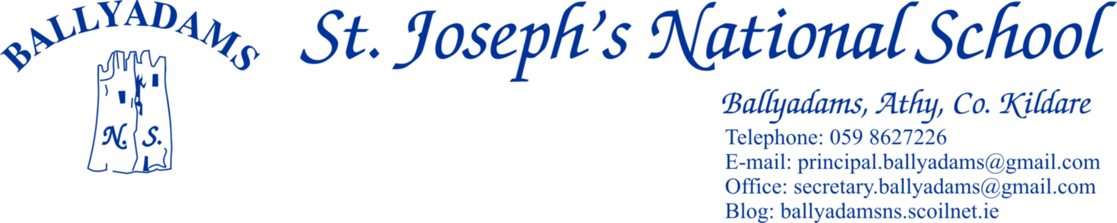

June 7th, 2016

Parents’ Council
The final Parents’ Council meeting of the year will take place on Tuesday June 21st at 8:30pm.
On behalf of the Board of Management, the staff and pupils, I’d like to sincerely thank the parent body in general and the Parents’ Council in particular for your tremendous efforts throughout the year. We are very fortunate to have such a dedicated and capable group working on behalf of the school.
We especially would like to thank our outgoing chairperson, Kathleen Crosby. Her hard work, support and co-operation on behalf of the school is greatly appreciated.
Cumann na mBunscol
Well done and congratulations to our wonderful hurling team who recently won their Cumann na mBunscol competition. They were magnificent in the final, coming from behind to defeat a previously unbeaten Paddock N.S. team. It completed a historic double for our Boys A team, as they added the hurling title to the football title they claimed earlier in the year. Well done to all our boys and girls who participated in Cumann na mBunscol activities in 2015/16. You were great ambassadors for our school.
Congratulations to 6th Class pupil Oisín Hooney, who was recently selected to represent Laois at half time in the 2016 All Ireland Football Final. It is a great honour for Oisín, his family, club and school. We wish him all the best on the day and hope he thoroughly enjoys the occasion. Oisín, Darragh Brennan and Tomás Byrne have also been picked to represent Laois in the Leinster Primary Schools Football Blitz this coming Friday. Best of luck lads!
Well done also to Emma Johnson and Niamh Crosby who represented Laois at half time in the Wicklow/Laois match recently.

Lunchtime Leagues
For the past number of weeks, the boys from 2nd, 3rd and 4th classes have been taking part in a lunchtime football league. The competition is heating up in the last few days and the boys are really enjoying the football. The 5th and 6th Class boys are looking after the managerial and officiating duties. Thank you to Mr. Mullooly for organising the league.
Meanwhile, the girls in 3rd, 4th, 5th and 6th Classes are taking part in a Euro 2016 themed soccer league. We are nearing the knockout stages of the competition and the girls are having great fun participating. Thank you to Ms. Walsh for organising the league and for giving up her lunch breaks to supervise.

School Tours
The children are eagerly anticipating their upcoming school tours. 5th and 6th Class will visit Baltinglass Outdoor Activity Centre on Monday, June 20th. On Tuesday, June 28th the remaining two tours will take place. 2nd, 3rd and 4th Class will travel to Gormanstown College in Co. Meath, while Junior Infants, Senior Infants and 1st Class will visit Lullymore. You should receive details of the tours with this newsletter. I’ll remind parents once more that the Aladdin online payment model is very popular with a number of parents and those who wish to register for online payments can contact Pam in the office for further details.

First Holy Communion
Well done to the children in 2nd Class who received their First Holy Communion on May 14th in Ballyadams Church. We thank Ms. Walsh, Mr. Mullooly, the parents and Fr. Dunne for helping to prepare the children for their big day.
Morning Supervision
I’ll remind parents that morning supervision does not begin until 9:10am each morning. Therefore, your child
should not be on the school premises before then.
Parking
The car park at the school is for staff parking only and should not be used for parking, dropping off or collecting
children. Not only does this apply at 3pm, but it also applies at 9:20am and 2pm. All parents are asked to use
the car park adjacent to the church. This request is not issued to inconvenience parents or adults, but rather with the
express purpose of ensuring safer access for all children to the school. Please bring this letter to the attention of
child minders and anyone who might drop or collect your child from school.

Graduation/End of Year Mass
Our end of year mass, which also serves as a Graduation Mass for our outgoing 6th Class pupils will take place in Ballyadams Church at 11 am on Thursday next, June 23rd. Pupils from the other two schools in the parish, The Sawn N.S. and Wolfhill N.S. will also be in attendance.

End of Year Reports
The end of year reports will be posted the week ending, Friday June 24th. In order for us to post the reports, we are asking each family to send in a stamped addressed envelope to the office before Friday, June 17th.
School Closure – June 10th
I’ll remind you that the school will be closed this Friday, June 10th for in-service for teachers on the New Primary Language Curriculum.

Re-opening & Closures 2016/2017
The school will reopen on Wednesday August 31st.
Closures 2016/2017
October 31st – November 4th - Halloween Midterm Break
Closing December 22nd and reopening January 9th – Christmas Holidays
February 23rd and 24th – Midterm Break
Closing April 7th and reopening April 27th – Easter Holidays
Closed Friday June 2nd and Tuesday June 6th with Bank Holiday
The school will close for the summer holidays on June 28th 2017.

Best Wishes Mrs McGahey
As you are probably aware, Mrs Audrey McGahey will retire at the end of this school year. She has given many years of tremendous service and dedication to the children of the parish, and we wish her all the best in her retirement. She’ll be greatly missed by us all in Ballyadams. Thank you Mrs McGahey.

Class Splits 2016/2017
Parents will be informed at the end of June regarding the class splits and the teachers assigned to each class for the 2016/17 school year.

Summer Holidays
The school will close for the summer break on Thursday, June 30th at 12:30 pm. Buses will run as normal at this time.

Mr. Fitzgerald
Principal

