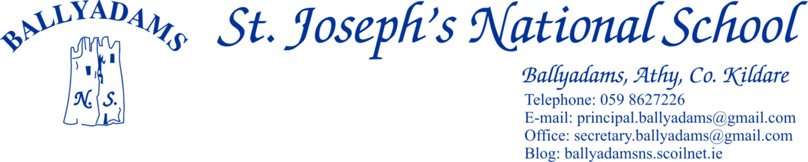





Telephone: 059 8627226

E-mail: [principal.ballyadams@gmail.com](mailto:principal.ballyadams@gmail.com)

Office: [secretary.ballyadams@gmail.com](mailto:secretary.ballyadams@gmail.com)

Website: ballyadamsns.com Twitter@ballyadamsns

***September Newsletter***

Welcome to the 2019/2020 school year. We wish all our pupils a happy, healthy and productive year in school. We would especially like to welcome all our new pupils in Ms. Doyle’s Junior Infants and congratulate them all for settling in so well to school.

**Opening Times and Morning Supervision**

Morning supervision does not begin until **9:10am** each morning. In the interests of health & safety we would ask that pupils are not on school grounds before 9.10am.

The Junior Infants will continue to finish at 12pm this week, but from next Monday, September 9th onwards, Junior Infants will finish at the normal time of 2pm.

**P.E. Times**

P.E. times for your child will be sent home by their class teacher this week. Tracksuits may be worn on these days. On **all** other days your child should be in their school uniform. Children who wish to play football/games on the playing field at lunch time should bring a spare tracksuit bottoms/shorts and football boots/old runners to school.

**Marking Clothes**

All tops, jumpers and coats should be clearly marked with your child’s name. There are a number of coats, jumpers and trousers left unclaimed in the school. You are welcome to call and claim items if you please.

**Parents’ Council**

The Parents’ Council A.G.M. will take place September the 16th at 8pm and you will receive notification by text. Our Parents’ Council are a very active and welcoming group and we would encourage you to attend the meeting on the night. New members are very welcome to join the Parents’ Council.

**Child Anxiety**

The Positive Parenting Programme or Triple P have organized a talk in relation to reducing anxiety in children. The talk is free and aimed at parents of children 6 – 12 years. The talk will examine the subject of anxiety amongst children and consider a constructive coping & problem solving approach to managing children’s anxious behaviour. The talk takes place Wednesday 11th September 2019 @ 7pm in St. Patricks N.S Ballylinan Co.Laois. The talk is free but places are limited and booking is essential. Please book your place with sinead.higgins@tusla.ie

**Parking**

The car park at the school is for **staff parking only** and should not be used for parking, dropping off or collecting children. **This applies at 3pm, 9:20am and 2pm.** All parents are asked to use the car park adjacent to the church. **Please bring this notice to the attention of child minders and anyone who might drop or collect your child from school.** From a Health & Safety for all our pupils, I would ask that good practice is observed in this area. Thank you for your anticipated cooperation.

**Cumann na mBunscoil Football & Athletics**

Our boys and girls will begin their respective football competitions next week. We wish all our players & coaches the very best of luck. Players are reminded to wear gum shields at all times. We will be participating in the Laois Cross Country championships in the coming weeks.

**Garda Vetting**

All parents/grandparents/older siblings who generously give their time freely to drive pupils to and from Cumann na mBunscol games and other school events must now be Garda vetted through the school. Only those vetted through the school can carry children other than their own to and from matches. Thank you to all parents who volunteer their time to bring the pupils to and from games. Vetting forms are available from Pam in the office.

**Lunches**

As you are all aware we have a Healthy Eating policy in the school. There is a Healthy Lunchboxes pamphlet included along with the newsletter detailing a range of practical healthy lunchbox tips.

**School Policies, School Website & Twitter**

We would ask that you familiarize yourselves with our school policies. Our policies are downloadable on our school website [www.ballyadamsns.com](http://www.ballyadamsns.com) . Follow St. Joseph’s N.S Ballyadams on @ballyadamsns for updates and information throughout the school year. Please contact Pam in the office if family contact information needs to be updated.

**Invitations**

Birthdays are great occasions and a source of immense joy to children. Organising your child’s birthday party is great fun but with classes of 20+ it would be unreasonable to expect that any family would invite every member of the class to a celebration. Invitations delivered at school can unintentionally cause hurt when one or more are not included. I would ask that no invitations are issued by children through the school.

**Requisites/E-Payments**

Most parents have now paid their requisites and book rental fees in full. We thank you for your co-operation. Remember that 24 Hour accident insurance cover from Allianz is provided within that payment. If you have any queries or wish to seek further information/clarification, please contact Pam in the office.

**Welcome Ms. Kieran**

We are delighted to welcome Ms.Kieran to our school for the next number of months. Ms.Kieran is teaching 1st and 2nd Class.

**Reminder of School Closures 2019/2020**

**Halloween Midterm:** Mon Oct 28th – Friday Nov 1st

**Christmas:** Close on Friday Dec 20th and reopen on Mon Jan 6th

**February Midterm**: Monday Feb 17th - Friday 21st (Week)

**Monday March 16th**

**Close for St. Patrick's Day Bank Holiday** - Tuesday March 17th

**Easter:** Close Friday 3rd April and reopen Monday April 20th

**Close for the Summer Holidays on Friday June 26th 2020**

**School Contact**

The school contact details are printed at the top of the page. As I am a teaching Principal I am unavailable to meet parents between 9:10am and 3pm.

If the need arises to contact me, or make an appointment, I ask that you please make an appointment through Pam in the office. You can contact Pam in the office between 9.30am and 1pm each day.

Is mise le meas,

Mr. R.Stapleton Principal