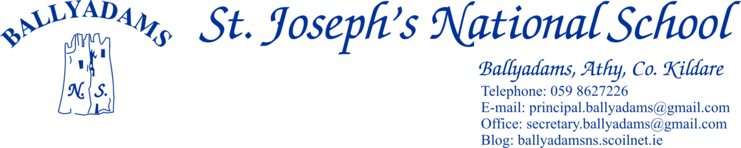
April 20th, 2016
Confirmation 2016
Congratulations to all our pupils in 5th Class and 6th Class who received the sacrament of Confirmation yesterday, April 19th in St. Mary’s Church, Wolfhill. We were fortunate to have Bishop Denis Nulty in attendance to perform the ceremony alongside Fr Dunne. We hope all the candidates and their families had a wonderful day. Well done to our choir also who sang beautifully throughout. The choir was made up entirely of our 3rd and 4th class pupils and we thank Ms. Kathleen O’Connor for all her time and effort in preparing them.

First Holy Communion
2nd Class will receive their First Holy Communion on Saturday, May 14th in Ballyadams Church. The 2nd Class pupils in Ms. Walsh’s and Mr. Mullooly’s classes have been busy preparing for the big day in recent months. We wish them the very best of luck. Photographer Thomas Anthony will be in the school on Tuesday May 17th to take pictures of the 2nd Class pupils in their Communion outfits for those who might like to purchase photographs.

Photographs
County Photos will be in the school on Friday May 27th to take individual and family photos of the children. They provide a wide variety of products for parents to choose from. They will send us brochures/information leaflets for your information in advance of their visit.

Enrolment
We are still taking enrolments for the school year 2016/17. Please contact Pam in the office for an enrolment form or for further details. Children must be at least four years old by September 1st 2016 in order to enrol. We ask you to encourage family, friends or neighbours to consider sending their children to our school if they are yet undecided.

Parking
The car park at the school is for staff parking only and should not be used for parking, dropping off or collecting children. Not only does this apply at 3pm, but it also applies at 9:20am and 2pm. All parents are asked to use the car park adjacent to the church. This request is not issued to inconvenience parents or adults, but rather with the express purpose of ensuring safer access for all children to the school. Please bring this letter to the attention of child minders and anyone who might drop or collect your child from school.

Proclamation Day
Well done to all the children for making Proclamation Day on March 15th such a successful and memorable day. Each class did a short performance, 5th and 6th Class read out the ‘Proclamation for a New Generation’ they had written and Garda Stephen O’Hanlon helped the three Ramsbottom sisters -Clare, Jane and Helen to raise the tricolour. The girls’ great granduncle Paddy Ramsbottom is credited with firing the first shots of the Rising in Colt Wood. The children then sang the national anthem. It was a fitting way for our school to mark the centenary of the 1916 Rising.

Swimming
Swimming lessons for Ms. Walsh and Ms. Holden’s classes will conclude on Thursday next, April 28th.

Pitch and Gear
We have reopened the school pitch for 1st Class – 6th Class pupils. However, they must wear football boots and spare tracksuit/shorts to play on the pitch. If we get a further spell of dry weather, we’ll allow the infants on the grass with their runners and school tracksuits.

Cumann na mBunscoil Hurling/Camogie
Our boys and girls have begun their respective hurling and camogie competitions. We wish all our teams the best of luck in their remaining games.

Athletics
Well done to the boys and girls who represented the school so well in the St. Abban’s Schools Day on Sunday last. Ballyadams N.S. secured an excellent medal haul on the day. James Nolan from St. Abban’s A.C.will be taking the pupils in 3rd-6th Class for a number of athletics sessions in the coming weeks.

Morning Supervision
I’ll remind parents that morning supervision does not begin until 9:10am each morning. Therefore, your child should not be on the school premises before then.

Music Generation Laois
We have been fortunate to link up with Music Generation Laois/Laois County Council to secure the services of music tutor Kim Melia for the final term. She is taking the pupils in 1st, 2nd and 3rd Classes each Wednesday for recorder lessons. These lessons are free of charge and recorders are provided for the children. However, if you wish to purchase your own recorder, you can do so at a cost of €7.

Closures
May 2nd – May 6th – Midterm Break
June 6th – Bank Holiday
The school will close for the summer holidays on June 30th 2016.

The calendar for the school year 2016/17 has not been finalised yet. We will inform you as soon as we have done so. However, the standardised holidays for the academic year 2016/17 are available on the Department of Education and Science website.

Mr. Fitzgerald
Principal

