



Telephone: 059 8627226

E-mail: [principal.ballyadams@gmail.com](mailto:principal.ballyadams@gmail.com)

Office: [secretary.ballyadams@gmail.com](mailto:secretary.ballyadams@gmail.com)

Website: www.ballyadamsns.com

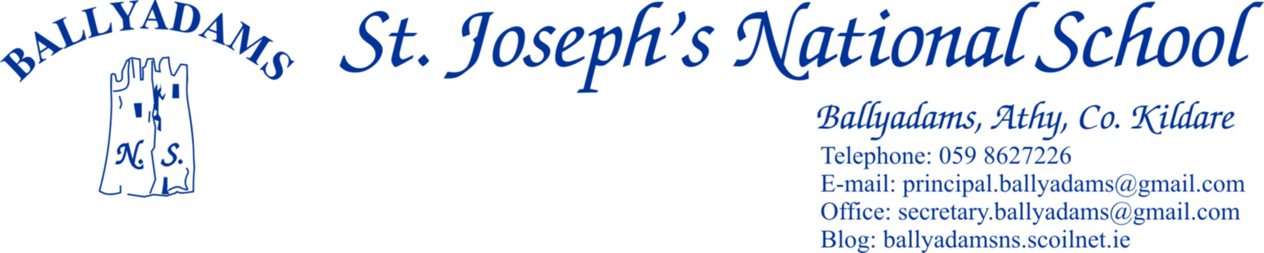

April 6th, 2017

***April Newsletter***

**Parents’ Council/Easter Raffle**

Our annual Easter Raffle will take place tomorrow, Friday. I’ll remind you to return your raffle cards before then if you haven’t already done so. Many thanks to the Parents’ Council, and especially all the 3rd Class parents for organising the reception after the First Confessions. Both the Parents’ Council and the Board of Management have asked me to thank all our parents and the wider school community for your continued generosity and support in our fundraising efforts to date.

**First Holy Communion**

2nd Class will receive their First Holy Communion on Saturday, May 13th in Ballyadams Church. The 2nd Class pupils in Mr Mullooly’s class have been busy preparing for the big day in recent months. We wish them the very best of luck.

**Book Fair**

Thank you to all those who contributed towards our book fair in March. The school will receive €477 worth of book vouchers in return.

**Pitch and Gear**

We have reopened the school pitch for 1st Class – 6th Class pupils. However, they must wear football boots and spare tracksuit/shorts to play on the pitch. If we get a further spell of dry weather, we’ll allow the infants on the grass with their runners and school tracksuits.

**Cumann na mBunscoil Hurling/Camogie**

Our boys and girls have begun their respective hurling and camogie competitions. We wish all our teams the best of luck in their remaining games. Our lunch time football leagues will commence after the Easter break.

**Active Schools**

Ms Walsh and her Active Schools committee have been very busy of late planning and working towards our Active Flag. Daily yard exercises, weekly ‘Class Runs’ and our monthly 10@10 have been ongoing. Pictures of the 10@10 are on the twitter page and website.

**School Website**

I’ll remind you that the parents’ section of our school website includes links to useful educational websites, previous newsletters, school calendar and a Parents’ Council page. You can visit us out at [www.ballyadamsns.com](http://www.ballyadamsns.com)

**School Tours**

Junior Infants, Senior Infants and 1st Class will visit Nore Valley Park on June 15th.

The 2nd and 3rd Class tour is to Let’s Go Camp in UCD on May 18th.

4th, 5th and 6th Classes will travel to Dublin on June 20th. They will take in the Ethiad Skyline Tour and Museum Tour in Croke Park before visiting the National Aquatic Centre in the afternoon.

A more detailed note and permission slip will be issued closer to the tour dates.

**Mental Health Awareness Workshop for Parents and Guardians**

This one-hour presentation in Laois Education Centre, Block Rd., Portlaoise on Wednesday April 26th at 7pm is aimed at parents or guardian of children in primary school.

As a result of this presentation, participants will:

* Gain a better understanding of mental health and the key issues impacting on the mental health of young people.
* Learn to promote positive mental health in children.
* Learn the value of listening as a way of supporting young people.
* Learn about other resources available to parents/caregivers.

The presentation will offer practical tips on how to best support and promote the mental health of all children and is not targeted at children with specific mental health issues. To book a place on the above course please contact Yvonne, Laois Education Centre at (057) 8672402. There is no fee and booking is essential. Places are reserved on a first-come, first-served basis.

**Parking**

Once again, I’ll remind parents that the car park at the school is for **staff parking only** and should not be used for parking, dropping off or collecting children. **Not only does this apply at 3pm, but it also applies at 9:20am and 2pm.** All parents are asked to use the car park adjacent to the church. As stated in the letter dated February 21st last, this request is not issued to inconvenience parents or adults but rather with the express purpose of **ensuring safer access for all children to the school**.

I’d also ask parents and drivers to be mindful of child/pedestrian safety at the church car park.

**Morning Supervision**

Morning supervision does not begin until **9:10am** each morning. Therefore, your child should not be on the school premises before then.

**School Closures**

Closing April 7th and reopening April 24th – Easter Holidays

May Bank Holiday Monday May 1st

Closed Friday June 2nd and Tuesday June 6th with Bank Holiday

The school will close for the summer holidays on June 28th 2017

The Department of Education and Skills recently released the standardised school holidays for the next three academic years. These are available on their website [www.education.ie](http://www.education.ie). A full list of school closures for the 2017/18 school year has not yet been decided but will be communicated to parents in the June Newsletter. However, we will be **reopening on Wednesday August 30th.**

Have a lovely Easter break.

Mr. T. Fitzgerald

Principal