



Telephone: 059 8627226

E-mail: [principal.ballyadams@gmail.com](mailto:principal.ballyadams@gmail.com)

Office: [secretary.ballyadams@gmail.com](mailto:secretary.ballyadams@gmail.com)

Website: www.ballyadamsns.com

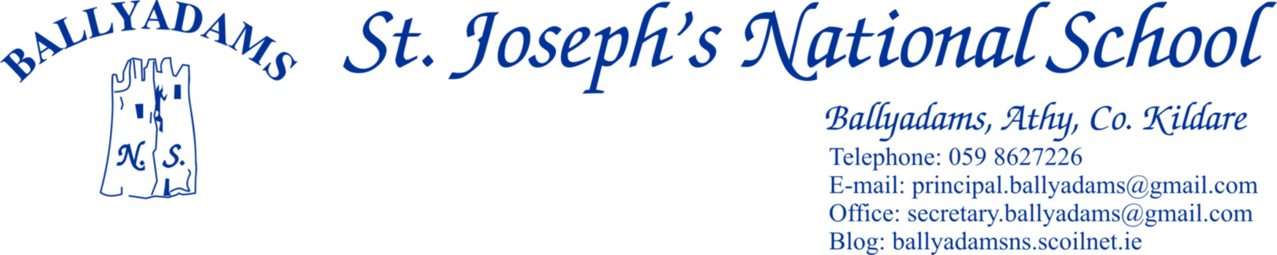

November 30th, 2017

***Newsletter***

**Christmas Shows**

As you are probably aware by now, the children are busy preparing for their upcoming Christmas shows. There will be two performances – Junior Infants, Senior Infants, 1st and 2nd Class will perform a ‘Musical Nativity’, while 3rd, 4th, 5th and 6th Classes will perform the musical ‘Oliver’. It has been decided to have a matinee on Tuesday December 19th at 1pm, plus two evening shows on Tuesday and Wednesday (19th and 20th) at 7pm. As both evenings fall on school nights, we are conscious of the need to conclude the shows at a reasonable hour. Therefore, we are asking parents to arrive on time and the shows will **commence at 7pm sharp**.

Our school hall can accommodate a certain number of people only. Therefore, both evening shows will be ticket only. We are limiting the number of tickets to 5 per family. We understand that some families may seek more, but we have to be fair to each family in the school. If there are spare tickets for either night, we will inform you closer to the night. Ticket orders can be placed with Pam in the office. **A reminder again that entry to the school will be ticket only**. Tickets are free of charge.

In line with Child Protection guidelines, patrons will not be allowed to take pictures or video the children on stage during the shows. We will have a videographer present on one of the night and we will make the DVDs available for sale at a cost of €10.

**Christmas Draw**

The Parents’ Council Annual Christmas Draw will take place during the interval of our shows on December 20th. This will be our major fundraiser for the current school year. There will be no cover charge for the Christmas Shows, so we’d be very grateful if each family in the school could buy/sell two books of tickets at a cost of €10. The Parents’ Council has been extremely fortunate to receive very good prizes for our raffle. If anyone would like to buy or sell some extra tickets, they are available from the school office. We are asking for tickets to be returned to the office by **Thursday December 7th** as any family who’ve returned tickets by then will be entered into a draw for a Christmas tree. There will also be a raffle among the pupils for a festive hamper. ***If you can spare any items for prize hampers, please drop them in to the school office by Friday December 15th.***

On behalf of the school and the Board of Management, I’d like to thank sincerely all those parents who have given up their time to sell tickets at local supermarkets recently and those who have secured raffle prizes.

**Annual Cake Sale**

Our Annual Cake Sale will take place in the New Year. 5th and 6th Class have their Confirmation Enrolment Ceremony at 11 o’clock mass on Sunday February 4th and it has been decided to have the cake sale afterwards. We’ll be in contact closer to the time but please try and support if possible.

**Santa Dash for St. Vincent de Paul**

Our Active School committee are organising a ‘Santa Dash’ on Thursday 21st. It is a fun run/walk. All family members are welcome to take part. Pupils and all other participants on the day are welcome to make a small donation towards the St Vincent de Paul Christmas Appeal. All proceeds will be donated to local St Vincent de Paul services. Junior Infants, Senior Infants, 1st, 2nd and 3rd classes will commence their run/walk at 12:30pm, while 4th, 5th and 6th classes will commence at 1pm. We would be grateful if we could have the assistance of parents to help us steward points along the route. If you are available to steward on the day from 12:30pm to 1:30pm please send a note in with your child to their class teacher or give Pam a ring in the office.

**Calendars**

The 2018 school calendars have been ordered and will be ready for collection shortly. We got great sponsorship this year and we are very grateful to those people/companies that supported us. Thank you to Kathleen Crosby once again for doing such a super job in putting it all together.

**Parent/Teacher Meetings**

If you were unable to attend the parent/teacher meetings, please contact your child’s class teacher through the office to arrange a new time and date.

**Halloween Walk/GOAL Jersey Day**

Thank you to all our pupils, parents and teachers who helped make our annual Halloween Walk such a wonderful success once more. Thank you also to everyone who contributed towards the €245 raised on October 13th for GOAL.

**Primary Science Fair**

Well done to Ms. Kirwan’s class who’ve been accepted to display their project at the Primary Science Fair on Saturday January 20th in Mary Immaculate College, Limerick. All of Ms. Rowan’s 4th Class and Mr. Fitzgerald’s 5th Class are welcome to travel with Ms. Kirwan’s class on the day. Further details will be provided in due course.

**New Sports Equipment**

We recently received sports equipment to the value of almost €9000 after securing a grant for 90% of the cost through the Clár Programme run by the Department of Culture, Heritage and the Gaeltacht. This included three new sets of GAA goalposts, catching nets at the back of the playing fields, indoor basketball rings/boards and one set of outdoor basketball rings and poles.

**Chess**

Paud O’Reilly finished a 5 week chess course with Ms. Kirwan’s 4th and 5th Class on Monday. The children really enjoyed the programme and have been busy practising at lunch time on wet days. It is hoped that they might in turn teach some of the other children in the school. Laois County Council have invited the pupils in Ballyadams to partake in the first Annual Laois Junior Chess Tournament on Saturday December 9th in Portlaoise College. All levels are catered for and no advance booking is required.

**Music Generation Laois**

1st and 2nd Class continue their Kinder Music programme every Wednesday with tutor Kim Melia, while 21 pupils from 3rd, 4th and 5th Classes are learning the saxophone, clarinet and flute. These pupils will perform as a group during the interval of our matinee on December 19th. There are no tickets required for the matinee and all parents are welcome to attend.

**Textaparent App**

Please read the flyer attached in relation to Textaparent. It is hoped that this will reduce our text messaging bill significantly. The app is free to download and the more parents who download it, the bigger the saving for the school.

**Morning Supervision**

I’ll remind you that morning supervision does not begin until 9:10am each morning. Therefore, your child should not be on the school premises before then.

**Christmas Holidays**

We will close on **Friday, December 22nd at 12pm** for the Christmas holidays. The school will reopen on **Monday, January 8th.**

As this is the last newsletter of the year, I’d like to extend a sincere thank you to all our parents for your wonderful support and assistance throughout the year. I wish you all a very happy Christmas and a wonderful 2018.

Mr. T. Fitzgerald

Principal