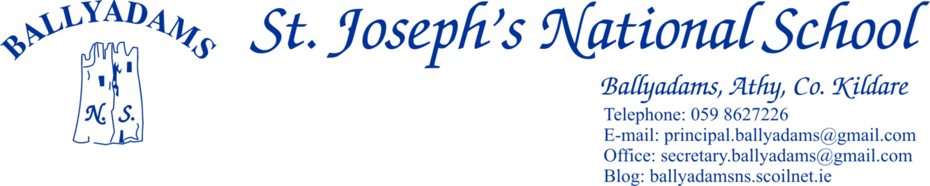





Telephone: 059 8627226

E-mail: [principal.ballyadams@gmail.com](mailto:principal.ballyadams@gmail.com)

Office: [secretary.ballyadams@gmail.com](mailto:secretary.ballyadams@gmail.com)

Website: ballyadamsns.com

***June Newsletter***

**Parents’ Council**

The final Parents’ Council meeting of the year will take place on Monday next, June 19th at 8pm. On behalf of the Board of Management, the staff and pupils, I’d like to sincerely thank the parent body in general and the Parents’ Council in particular for your tremendous efforts throughout the year. We are very fortunate to have such a dedicated and capable group working on behalf of the school.

**Cumann na mBunscol**

Hard luck to our boys hurling team who were beaten in their final recently. It was a magnificent achievement to reach the final. Our camogie team were beaten by Ballyroan in the semi-final. It was great to see them improve so much as the competition progressed. Well done girls. Congratulations to 6th Class pupils Seán Brennan and Cormac Murphy who were chosen to represent Laois at the Leinster Primary Schools Football Blitz last week.

**Lunchtime Leagues/Active Schools Week**

For the past number of weeks, the boys from 2nd, 3rd and 4th classes have been taking part in a lunchtime football league. The 5th and 6th Class boys are looking after the managerial and officiating duties. We’re looking forward to the final this coming Friday. Thank you to Mr. Mullooly for organising the league. As Ms Walsh and our Active Schools Committee continue to work towards our Active Schools Flag, we are partaking in an Active Week all this week. Children are allowed to wear their tracksuit each day. Blue/navy shorts are also allowed. There is some better weather forecasted for later in the week so sun screen should be applied before coming to school.

**School Tours**

2nd and 3rd Class enjoyed a great day at the Let’s Go Camp in UCD recently. The other classes are eagerly anticipating their upcoming tours. This coming Thursday, Junior Infants, Senior Infants and 1st Class will visit Nore Valley Park in Kilkenny. 4th, 5th and 6th Class will travel to Dublin on June 20th. They will take in the Ethiad Skyline and Museum Tours at Croke Park before visiting the National Aquatic Centre in Blanchardstown.

I’ll remind you that the Aladdin online payment model is very popular with a number of parents and those who wish to register for online payments can contact Pam in the office for further details.

**First Holy Communion**

Congratulations to the children in 2nd Class who received their First Holy Communion on May 13th in Ballyadams Church. We thank Mr Mullooly, the parents and Fr. Dunne for helping to prepare the children for their big day. Well done to our brilliant choir on the day also and thank you to Ms Walsh and Ms Holden for preparing them so well.

**STEM Plaque of Excellence**

Recently we applied for the Discover Primary Science STEM Plaque of Excellence. STEM stands for ‘Science, Technology, Engineering and Maths’. We had a number of criteria to fill in each area. The staff also completed three professional development workshops. We’re delighted to announce that we achieved the desired standard and we’ll soon receive our Plaque of Excellence. Well done to all the pupils and teachers who took part in the various activities throughout the year. You can view our dedicated STEM page on our school website [www.ballyadamsns.com](http://www.ballyadamsns.com)

**Morning Supervision**

Morning supervision does not begin until **9:10am** each morning. Therefore, your child should not be on the school premises before then.

**Parking**

Once again, I’ll remind parents that the car park at the school is for **staff parking only** and should not be used for parking, dropping off or collecting children. **Not only does this apply at 3pm, but it also applies at 9:20am and 2pm.** All parents are asked to use the car park adjacent to the church. As stated in the letter dated February 21st last, this request is not issued to inconvenience parents or adults but rather with the express purpose of **ensuring safer access for all children to the school**.

I’d also ask parents and drivers to be mindful of child/pedestrian safety at the church car park.

**End of Year Reports**

The end of year reports will be ready to be sent next week. This year, we are giving parents the option of receiving their child’s report via email. Please provide Pam in the office with a working email address if you’d like to avail of this option. Otherwise, we are asking each family to send in a stamped addressed envelope to the office before Friday, June 16th.

**Absences/Roll Call**

In the report cards, it will state the number of days absent throughout the year. In compliance with Circular 0028/2013, we must complete the roll within one hour of instruction time commencing. It also states that *‘a pupil will be marked either present or absent at the time of roll call and there will be no provision for adjusting the Roll Book (Leabhar Rolla) where a pupil subsequently does not complete the full school day or arrives after the roll call’.* Therefore, if your child is late coming to school and has a note to explain why they’re late, we still cannot adjust the roll once it’s completed. However, at the end of year presentations, late days (with notes) will not be considered absences when handing out certificates of attendance.

**Book Lists and Uniforms**

Book lists for the 2017/18 school year will be distributed shortly. As always, we are mindful of keeping the costs for parents to a minimum. We will continue to invest and update books in our book rental scheme. Once more school tracksuits are available through Shaw’s in Athy. They have introduced some new payment plans for parents and guardians. Details can be found on the homepage of our school website.

**Graduation/End of Year Mass**

Our end of year mass, which also serves as a Graduation Mass for our outgoing 6th Class pupils, will take place in Ballyadams Church at 11am on Thursday, June 22nd. Pupils from the other two schools in the parish, The Sawn N.S. and Wolfhill N.S. will also be in attendance.

**School Closures 2017/2018**

**Reopening Wednesday August 30th**

**Halloween Midterm:** Mon Oct 30th – Friday Nov 3rd

**Christmas:** Close on Friday Dec 22nd and reopen on Mon Jan 8th

**February Midterm**: Feb 15th and 16th

**Close for St. Patrick's Day Bank Holiday** - Monday March 19th

**Easter:** Close March 23rd and reopen April 9th

**May Bank Holiday:** Close Friday May 4th and Tuesday May 8th

**June Bank Holiday**: Close Friday June 1st and Tuesday June 5th

**Close for the summer holidays on Thursday June 28th 2018**

The school will close at 12pm on Wednesday June 28th for the summer holidays. Buses will run as normal at that time.

Mr. T. Fitzgerald

Principal