Learning Framework 27th -29th April J&S Infants
Hi everyone!

I hope you are all keeping well. I am missing school and seeing you all every day but hopefully we will see each other soon. You are all doing a great job avoiding the spread of germs. After the experiment we completed last week, you are experts on it and could give Dr. Tony Holohan a run for his money!

If you need to contact me or want to share pictures of your work, you can email me by email on rachel@ballyadamsns.com

Keep on working hard and being extra kind at home. I am so proud of how well you are doing.
Mrs Doyle
New platform for sharing work | Monday, Tuesday and Wednesday are included in this document.  From this Thursday 30th April all work will be shared on Aladdin Connect. Details of how to access this have already been circulated by Mr Stapleton.
Other material for the week | - Please continue to use the Collins Big Cat readers online. If you cannot access these, any books you have at home or other online readers are fine. Chat about the stories and the characters. Make some predictions and visualisations too.  - PE with Joe Monday to Friday at 9am  - RTE School Hub Monday to Friday at 11am  - Cúla4 ar Scoil Monday to Friday 10am
Tasks for the week | - 2 pages of Just Handwriting  - One page of Free Writing  - Do 2 extra kind things each day  - Enjoy some quiet time by sitting somewhere comfortable and spending 10 minutes (or more if you want) a day reading
Monday | Phonics  Look at the worksheet entitled “Name Scavenger Hunt” and see if you can work out who sent the pictures. You can complete Pictures 1-4 today.  I received lots of pictures for the name scavenger hunt but if you didn’t get a chance to send yours yet then you can still send it to me and I will include your picture on another worksheet.  Reading and Maths  Complete the worksheet attached for today.  Gaeilge  For the coming weeks we are going to be using Abair Liom B for our Gaeilge lessons. It will mean registering for Folens. Details and instructions are below.  How to log in:  Go to www.folensonline.ie and click register  Select Teacher and you will see the screen below.  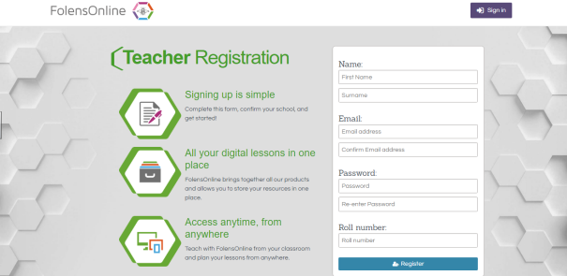  Fill in a username, e-mail, password and for the roll number type Prim 20  Remember your details for next time.  Search for Abair Liom B, pictured below.  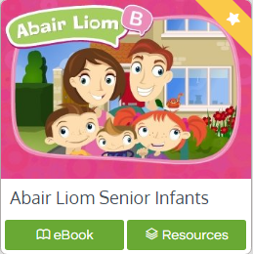  When you click on Resources, there will be a dropdown menu for Lessons. Click on 11. Ag siopadóireacht le Mamaí.  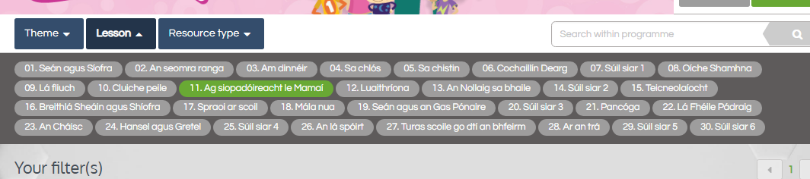  Now you are in and can view the lesson resources and games.  You can also go back to the ebook and see what activities are there on Pages 40-43.
Tuesday | Phonics  Look at the worksheet entitled “Name Scavenger Hunt” and see if you can work out who sent the pictures. You can complete Pictures 5-8 today.  Reading and Maths  Complete the worksheet attached for today.  Gaeilge  Continue with the Abair Liom B online activities  PE  This month in PE we would have been doing the strand Games and the strand unit Creating and Playing Games. So this is why I want you to do some of the following activities whenever you have time.  - A relay around the house garden. You will need someone to do the relay with you so ask your family nicely! You can’t go until you have been given the running object (maybe use a soft toy as a baton)  - Playground games; think of some of your favourite games that the Playground Leaders usually play with you. Teach them to your family and off you go! Some ideas are Cat and Mouse, What time is it Mr Wolf?, Duck, duck, goose.  - You can do PE with Joe on YouTube any time you like too.
Wednesday | Phonics  Look at the worksheet entitled “Name Scavenger Hunt” and see if you can work out who sent the pictures. You can complete Pictures 9-11 today.  Reading and Maths  Complete the worksheet attached for today.  Gaeilge  Continue with the Abair Liom B online activities  Music  There are lots of interesting videos on YouTube that can teach us about Music. This one uses hand signs to show what note you are singing. Have a look and give it a go!  Here is the link: https://www.youtube.com/watch?v=HdRkFFdkhm4

