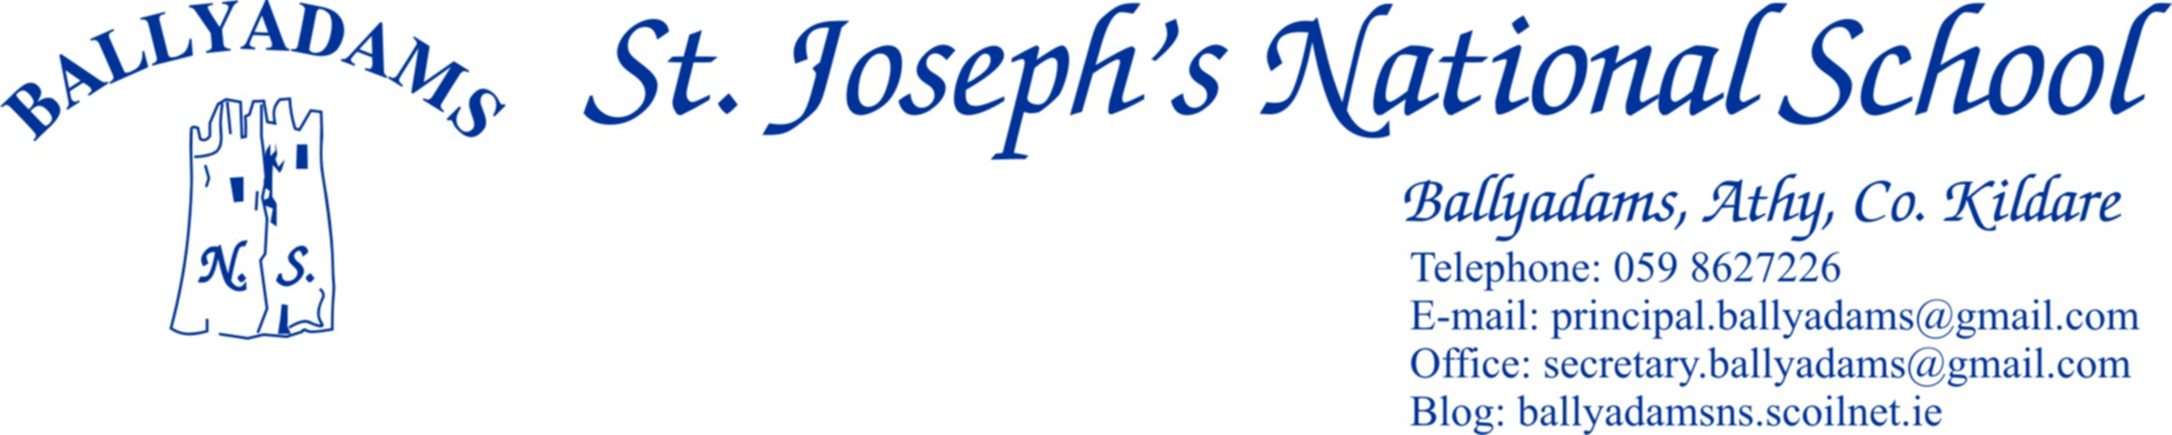





***April Newsletter***

**Parents Council**

Preparations are well underway for the Easter Raffle taking place on Friday. Please return your raffle cards to the school by the Thursday 11th. I would like to take this opportunity to thank the Parents Council for their tremendous efforts throughout the school year. Thank you to our parents for the continued goodwill and generosity you extend towards school initiatives and fundraising activities.

**Catholic Schools Week & celebrating Grandparents Day.**

We were delighted to welcome our Grandparents to the school as part of Catholic Schools Week. It was wonderful to see so many excited and enthusiastic grandparents visiting classrooms where they were treated to some wonderful displays of talent by our boys and girls. Many of our grandparents shared stories about their lives and experiences in Ballyadams N.S in years past. Afterwards there were refreshments provided in the PE Hall. Many thanks to all involved for helping to create a truly special and memorable day.

**First Holy Communion Class**

Our Communion Class will celebrate their First Confession the 10th April at 2pm in the Church. There will be a reception in the school afterwards. Many thanks to all parents who have volunteered to help out on the day and provide refreshments. The boys and girls will celebrate their First Holy Communion May 18th. The teachers would like to commend all the boys and girls for the respect and commitment they have shown throughout their First Holy Communion journey. A special word of thanks to Ms Kirwan for her hard work and dedication towards preparing the children for their Holy Communion and our wonderful School Choir under the guidance of Ms Rowan. We wish the children every blessing as they celebrate this important milestone in their spiritual and school lives.

**Internet Safety Evening**

We would like to invite all parents to the Parent Internet Safety Seminar in Ballyadams N.S Thursday 9th May 7 – 8pm. The seminar provided by Internet Safety Company ‘Zeeko’ will involve internet safety sessions with our pupils during the day, tutorials with our teaching staff after school and an information session with parents in the evening. We believe in the importance of best practice in terms of safeguarding the online wellbeing of the boys and girls. We will be issuing an information leaflet upon our return after the Easter Break. I hope as many parents as possible can attend for what promises to be a worthwhile and beneficial seminar.

**S.E.N Report**

We recently received our report for the Provision of Education for the pupils with Special Educational Needs from the Department of Education. I am pleased to report to the school community the findings reflect extremely positively upon the teaching and learning provided to all our pupils in St. Joseph’s N.S Ballyadams. The full report can be found on the Department website.

**Enrolment**

We are still taking enrolments for the school year 2019/20. Please contact Pam in the office for an enrolment pack. Our school website [www.ballyadamsns.ie](http://www.ballyadamsns.ie) and twitter @ballyadamsns offer an excellent insight into school life in St. Joseph’s N.S Ballyadams.

**Active Schools**

We continue to take pride in our status as an Active School. We realize that healthy bodies contribute to healthy minds. The boys and girls from all classes practice their ‘10@10’ active movements and exercises at 10am the first week of each month alongside active school lines after Lon beag and Lon Mor. The activity is expertly marshalled by the boys and girls on our Active Committee. We look forward to celebrating Active School week in Ballyadams in the month of May.

**Quiz Success**

Each year teams from Ballyadams represent the school with distinction in the St. Abban’s Quiz. Congratulations to all the teams who entered this year and well done to the teams who enjoyed overall success in the 34th Annual Quiz claiming silverware and having great fun in the process. Maith sibh.

**Book Fair & Author Visit**

We held our annual Book Fair in the last number of weeks. This year €1,215 was raised. We are appreciative of the support received and 60% of the money collected will go towards funding new books for the school.

March 28th marked the arrival of celebrated children’s author Sheena Wilkinson to Ballyadams. Sheena met with both our 5th and 6th classes, reading excerpts from her latest novel ‘Star By Star’ and fielded excellent questions from both classes. We were thrilled to welcome Sheena to our outdoor classroom during the visit.

**Friendship Week**

The gospel teaches us to ‘Love one another as I have loved you’. We will be celebrating Friendship Week in Ballyadams on our return from the Easter holidays. Our message is simple and true for each boy and girl and class in our school. T.E.A.M. Together Everyone Achieves More. We will be organising interesting Art Ideas, cooperative Friendship Games amongst more activities to celebrate our values of fairness, tolerance and respect for others.

**Sport**

Our Cumann na mBunscol hurling campaigns are up and running for both Boys and Girls teams. We wish the boys and girls every success throughout the competitions. Many thanks to all the parents who provide transport to school teams. Our 3rd & 4th classes took part in the Cumann Na mBunscol Gaelic Football blitz recently held in Killeshin. 5th and 6th Class performed excellently in the recent Leinster Rugby Blitz in Athy R.F.C. Our Leinster Rugby Coach Tadhg Kelleher provides coaching to all the classes from Infants to 6th each Friday. Our thanks to Tadhg.

Well done to the boys and girls from Ms Kirwan and Ms Rowan’s classes who recently completed their swimming lessons.

**School Uniform**

Please ensure children wear the school uniform, where practicable on non P.E and sport related days. Thank you for your cooperation.

**Playing Pitches**

1st – 6th classes are encouraged to use the pitches at lunchtimes provided they are wearing spare footwear and spare tracksuit / shorts. We hope to schedule time and space for the Junior & Senior Infants to use the pitch area after Easter. Thanks to our Playground Leaders for setting a fine example for our younger pupils at break times.

**Morning Supervision & Parking**

**Morning supervision begins at 9.10am each morning** and I would ask that children are not on the school premises before that time.

Please bear in mind the staff car park is for **staff only.** The Church Car Park is the designated drop off & collection point. Thank you for your cooperation**.**

**School Closures**

* **Easter Holidays** – close on April 12th and reopen on April 29th
* **May Bank Holiday** – Monday May 6th
* **European & Local Elections** – Friday May 24th
* **Staff In-service Day** – Friday May 31st
* **June Bank Holiday – Monday and Tuesday June 3rd and 4th**
* **Summer Holidays** – Closing on Friday June 28th 2019.

***\*Please note the school will be closed Friday 24th of May for the European Election & Friday 31st for staff training for the Primary Language Curriculum.***

We will be finalising a return to school date and the school calendar for the 2019/20 school year in the next term. Details of the 2019 / 20 school calendar will be outlined in the June Newsletter.

My thanks to all members of school community for your valued contribution towards school life in Ballyadams.

I wish you all a pleasant Easter break.

Ni neart go cur le cheile.

Rory Stapleton

Principal